**Montgomery College**

**CMSC 203**

**Assignment 4 Implementation**

1. Complete a UML class diagram for all classes in a Word document (or .uml file if you use UmlScluptor).

word link for UML diagrams

[Document2.docx](https://montgomerycollege0-my.sharepoint.com/:w:/g/personal/cperezle_montgomerycollege_edu/ESTNj6pMUwtPqZv8lkmbIE8BMMlnVK2FrS2rwCZEHl07Vw?e=uzUuDV)

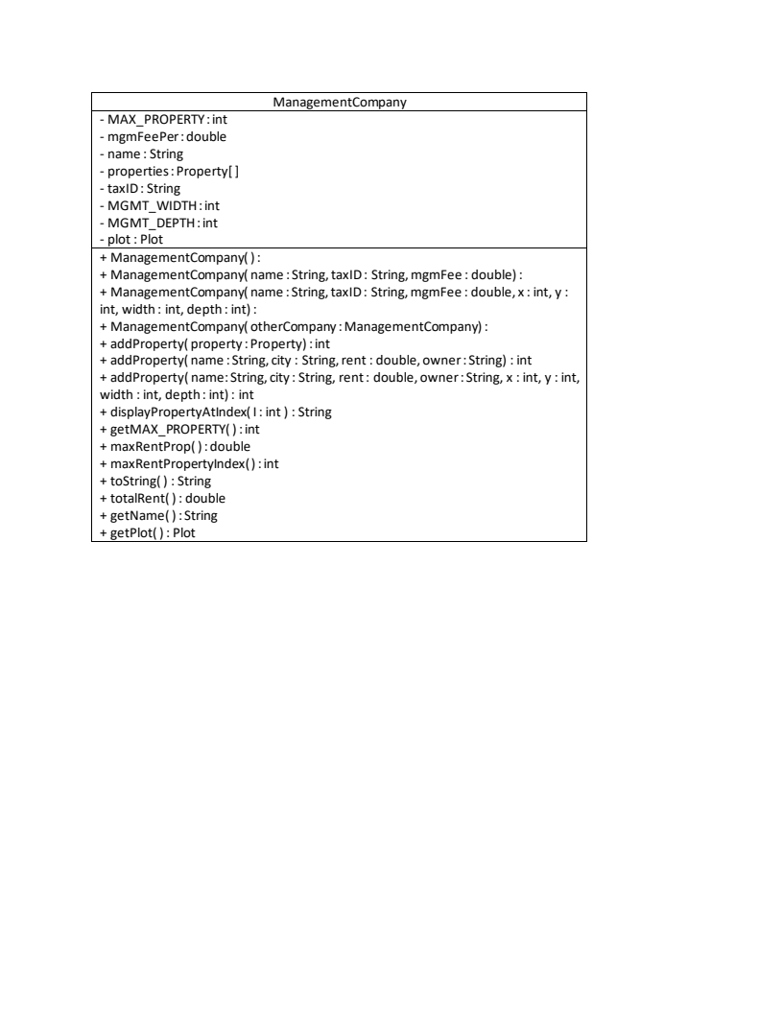

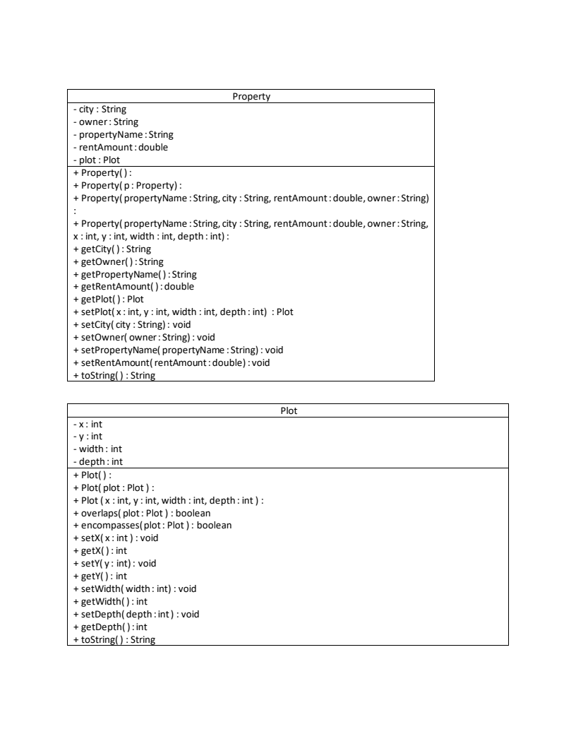

2. Write the pseudo code for the primary methods specified in ManagementCompany.java, and Plot.java in a Word document. Do not just list what gets read in a printed out, but explain the algorithm being used.

google docs link for your convenience

<https://docs.google.com/document/d/1d2wHZ1pADUrhJOcv2I67pTk7kbc8K_-OZhzv6R6Jj-w/edit?usp=sharing>

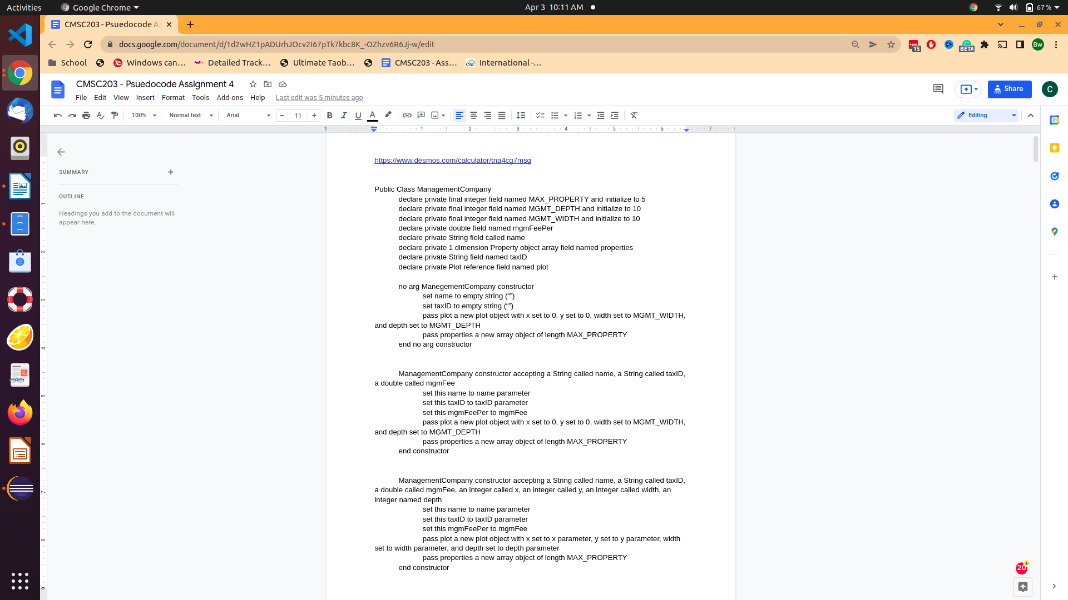

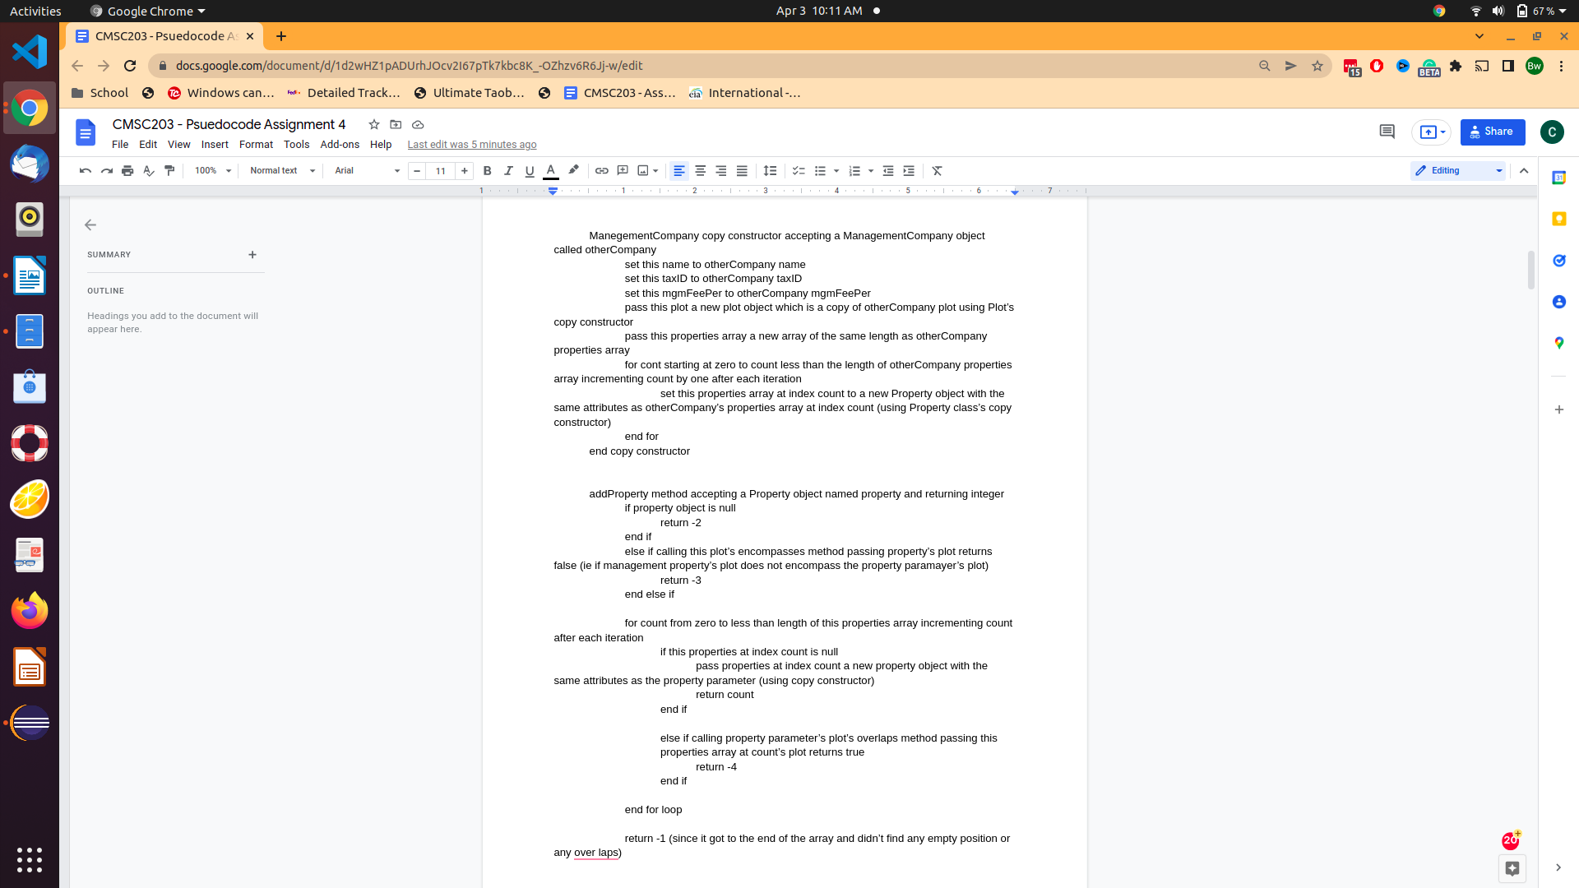

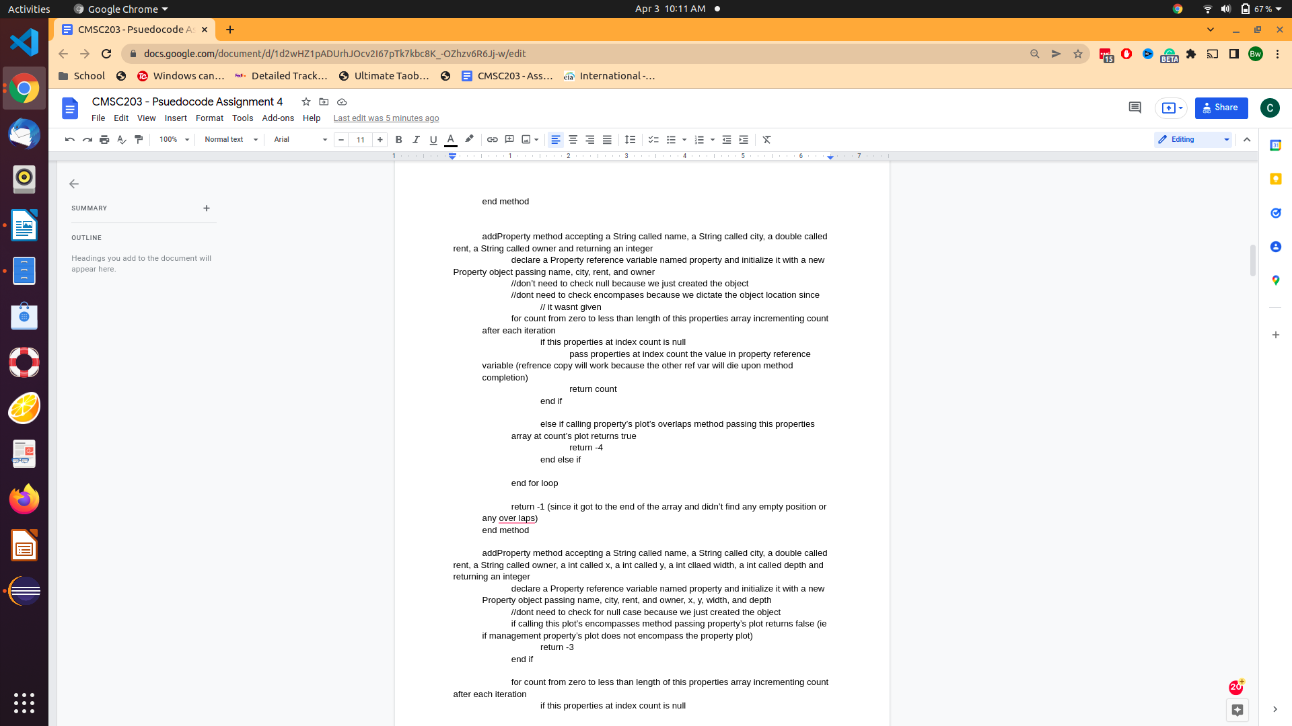

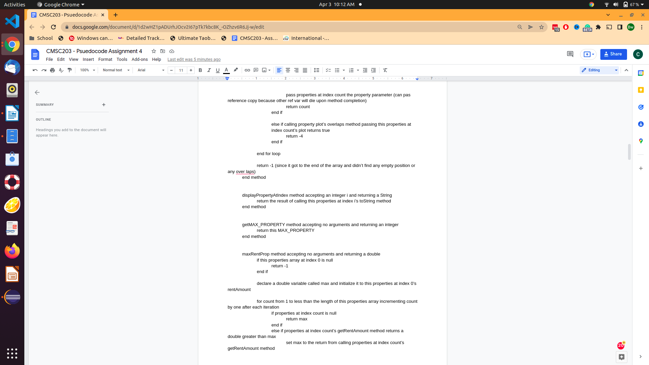

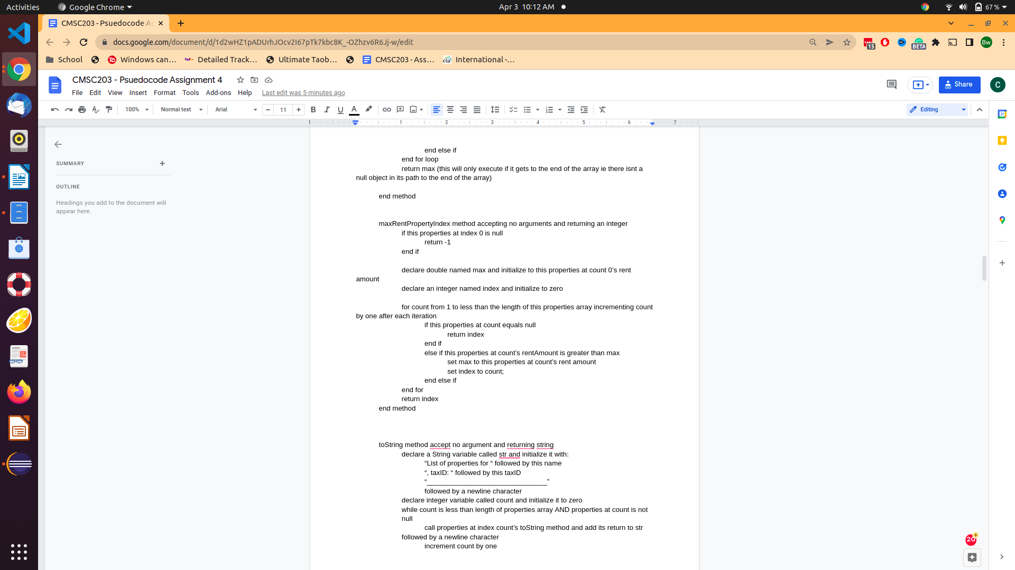

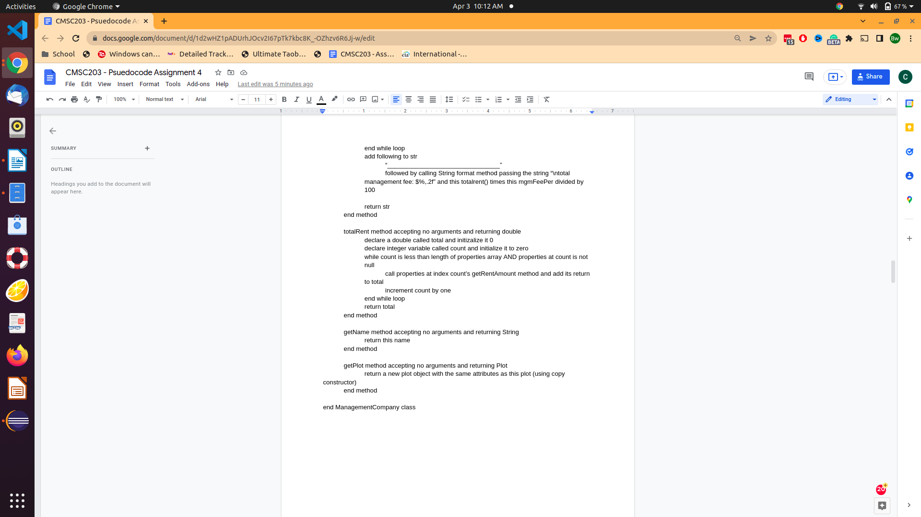

Refer to the **Pseudocode Guideline**on how to write Pseudocode.

**Pseudocode Guideline**

Pseudocode is code written for human understanding­ n­ot a compiler. You can think of pseudocode as “English code,” code that can be understood by anyone (not just a computer scientist). Pseudocode is not language specific, which means that given a block of pseudocode, you could convert it to Java, Python, C++, or whatever language you so desire.

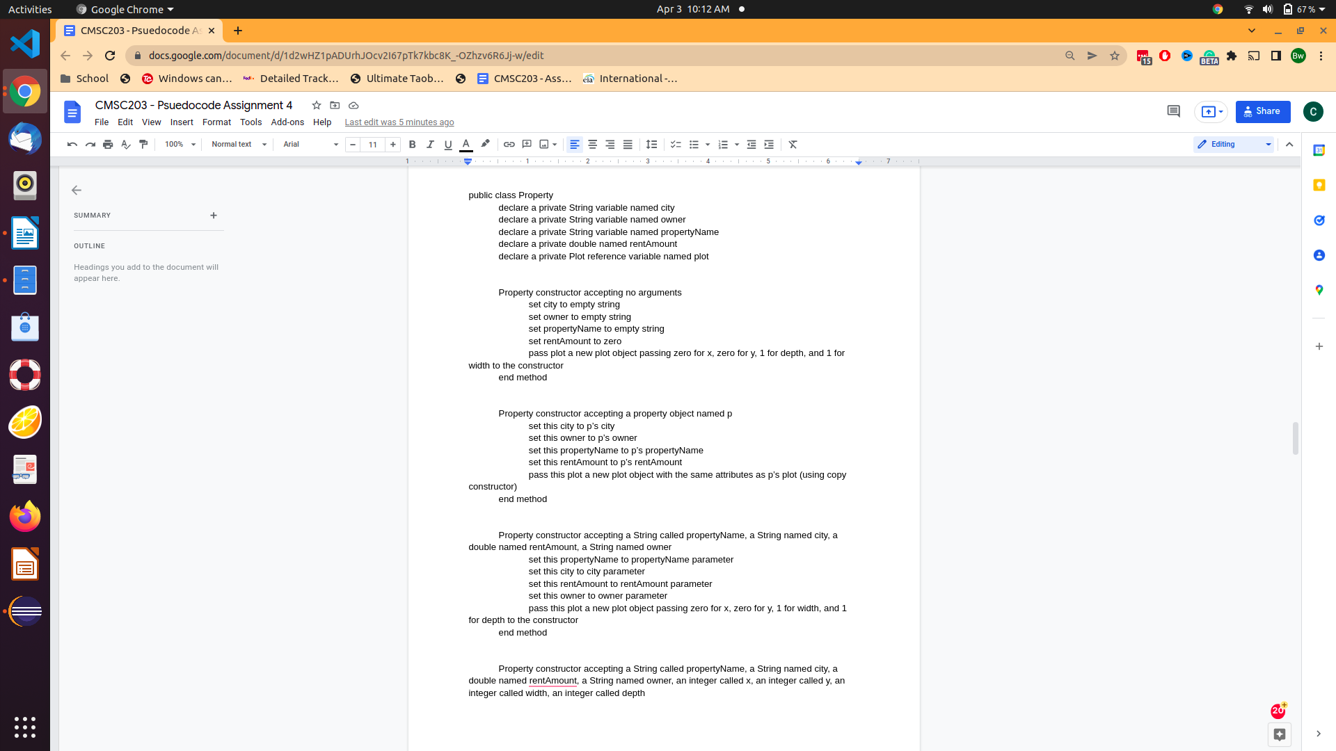

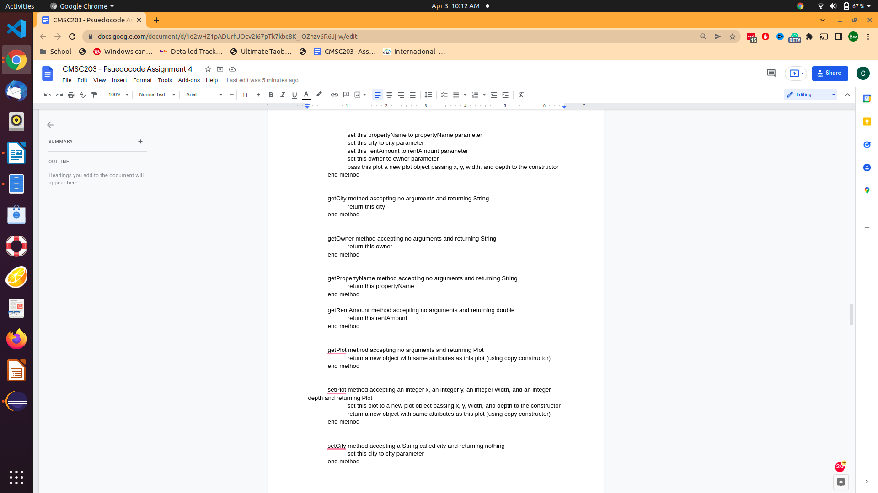

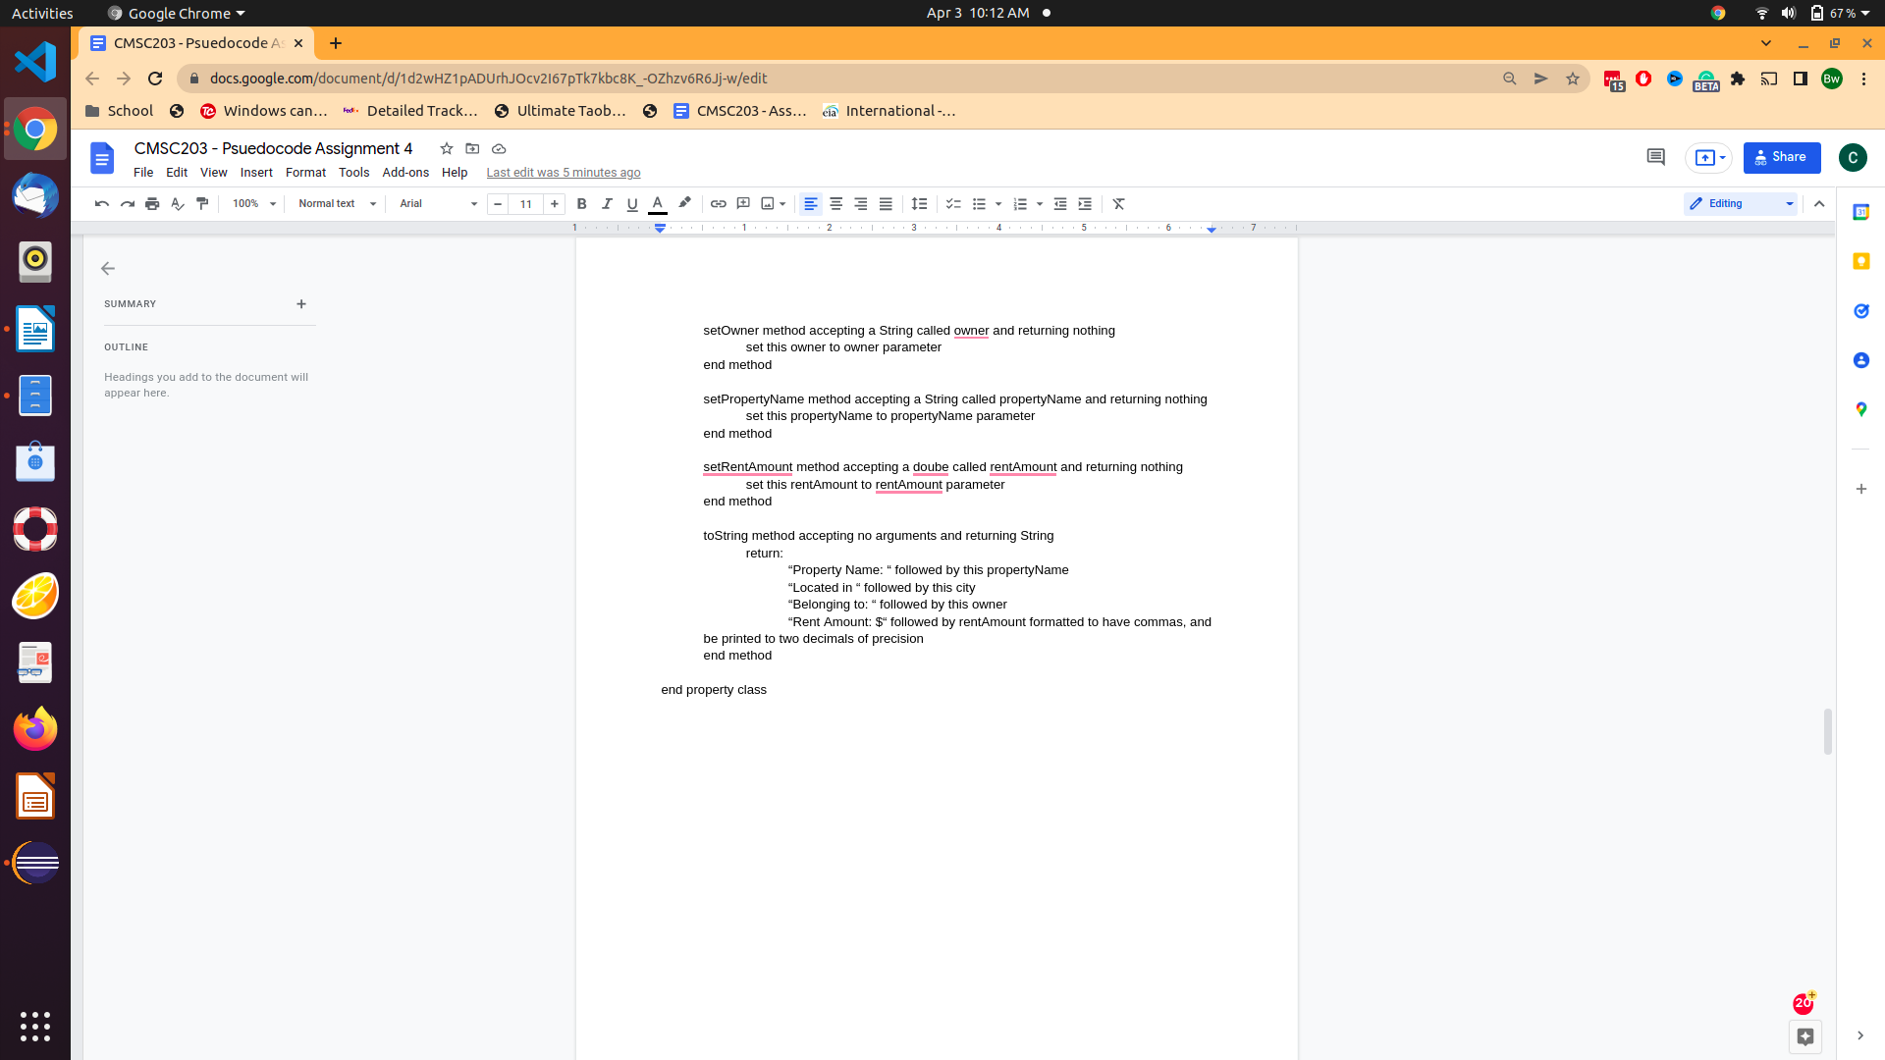

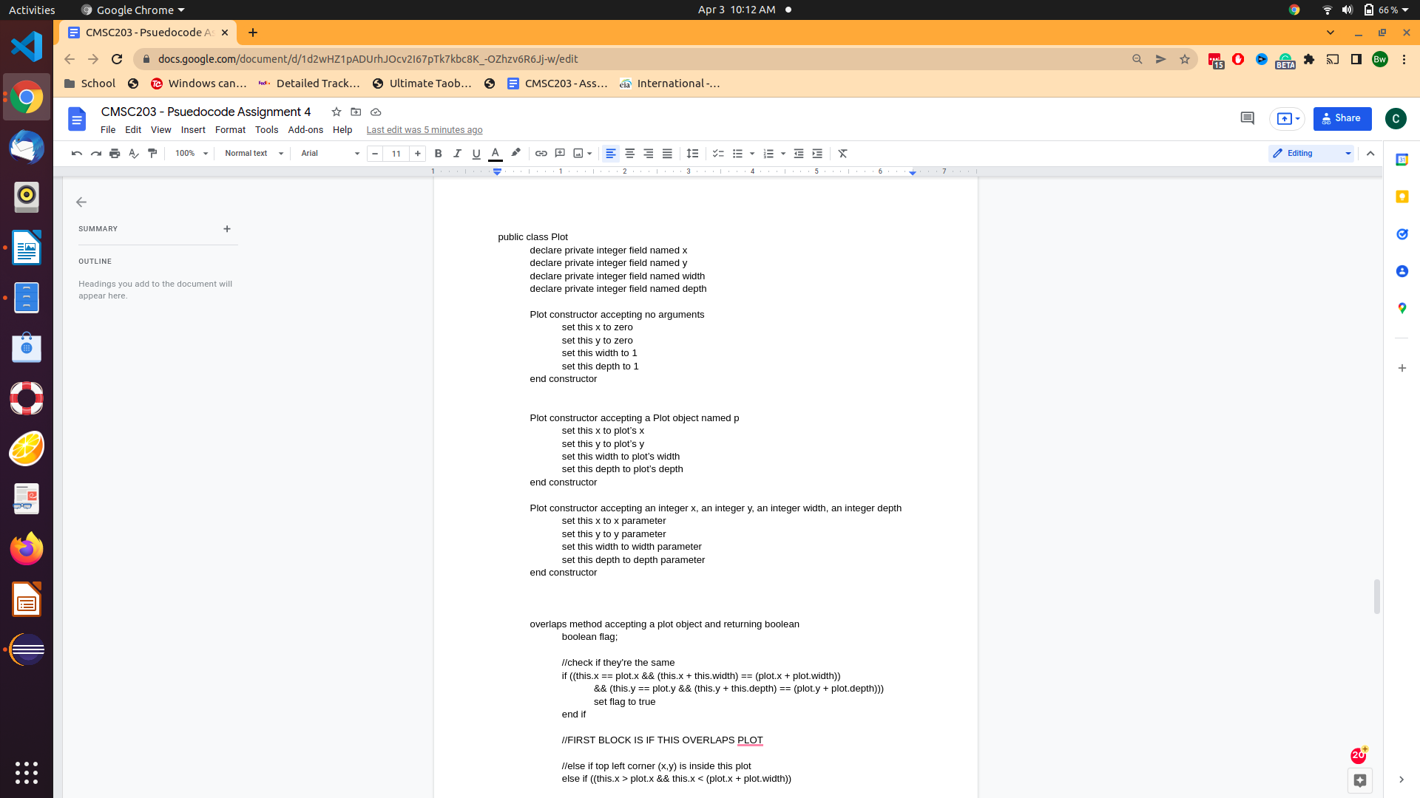

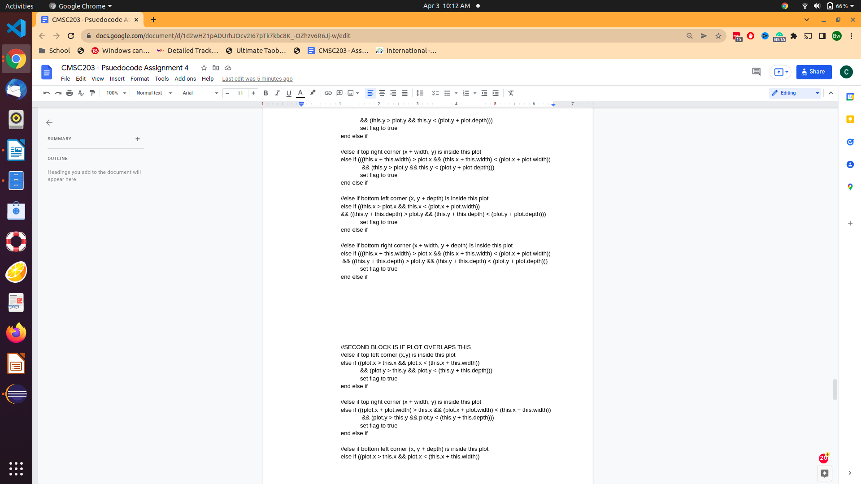

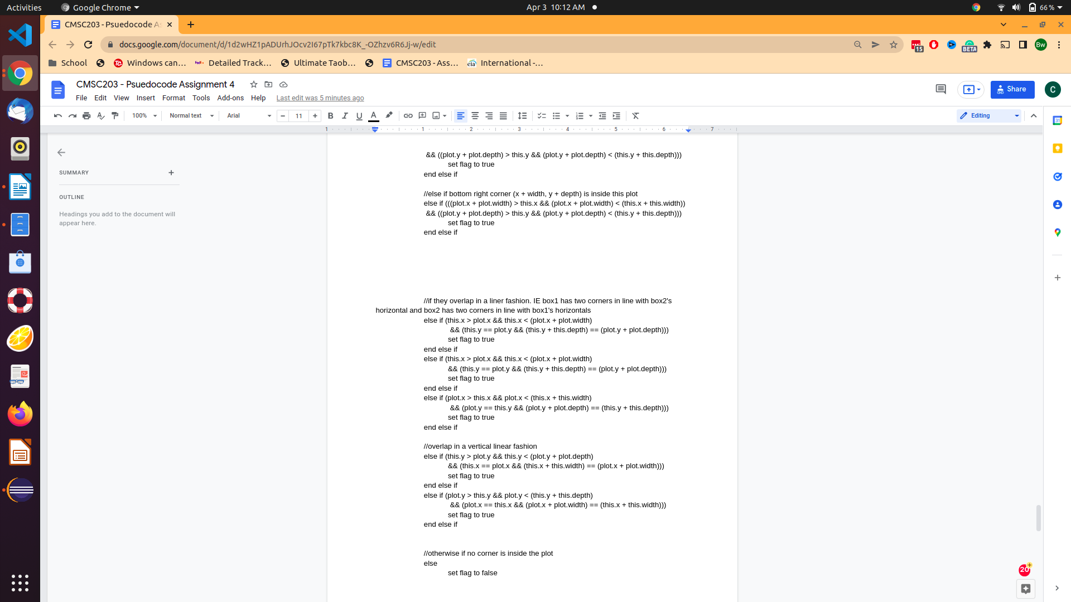

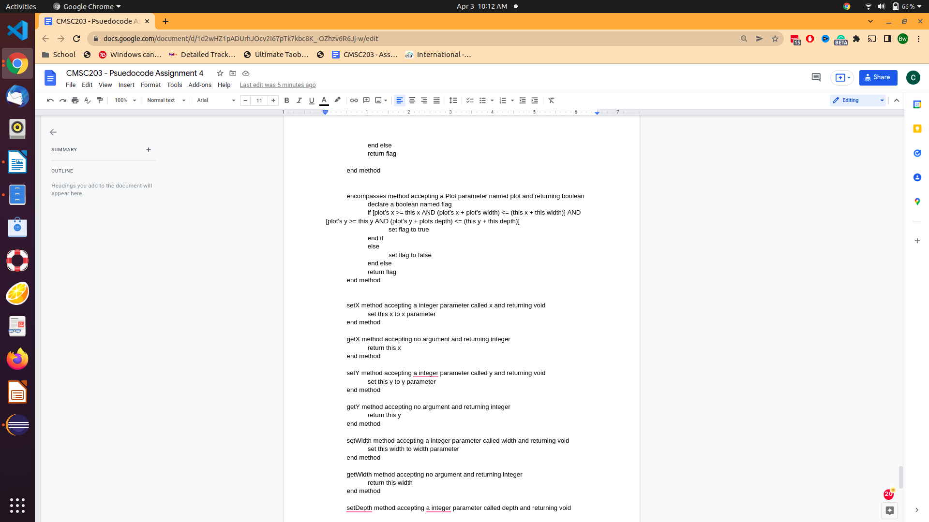

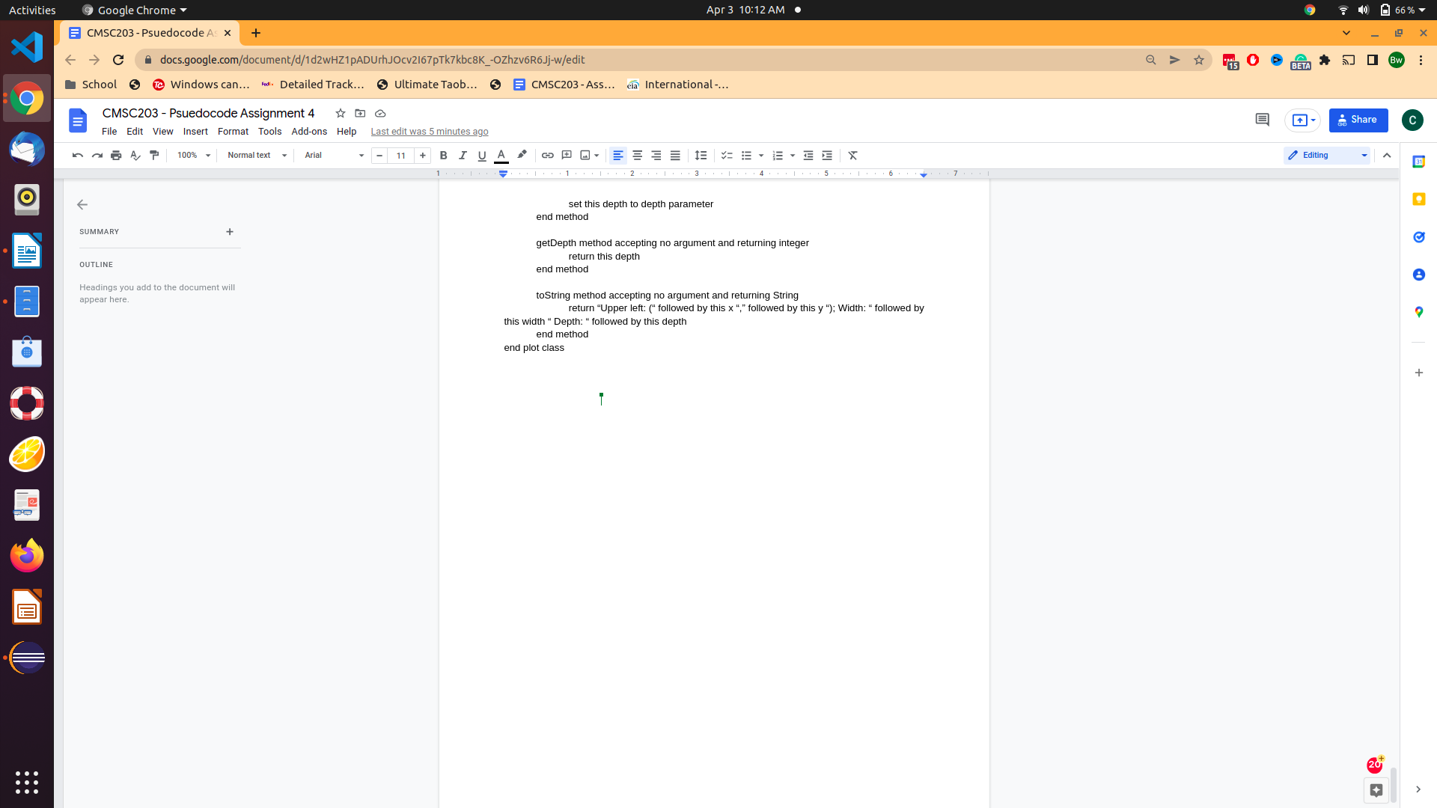

3) Screenshots of GUI

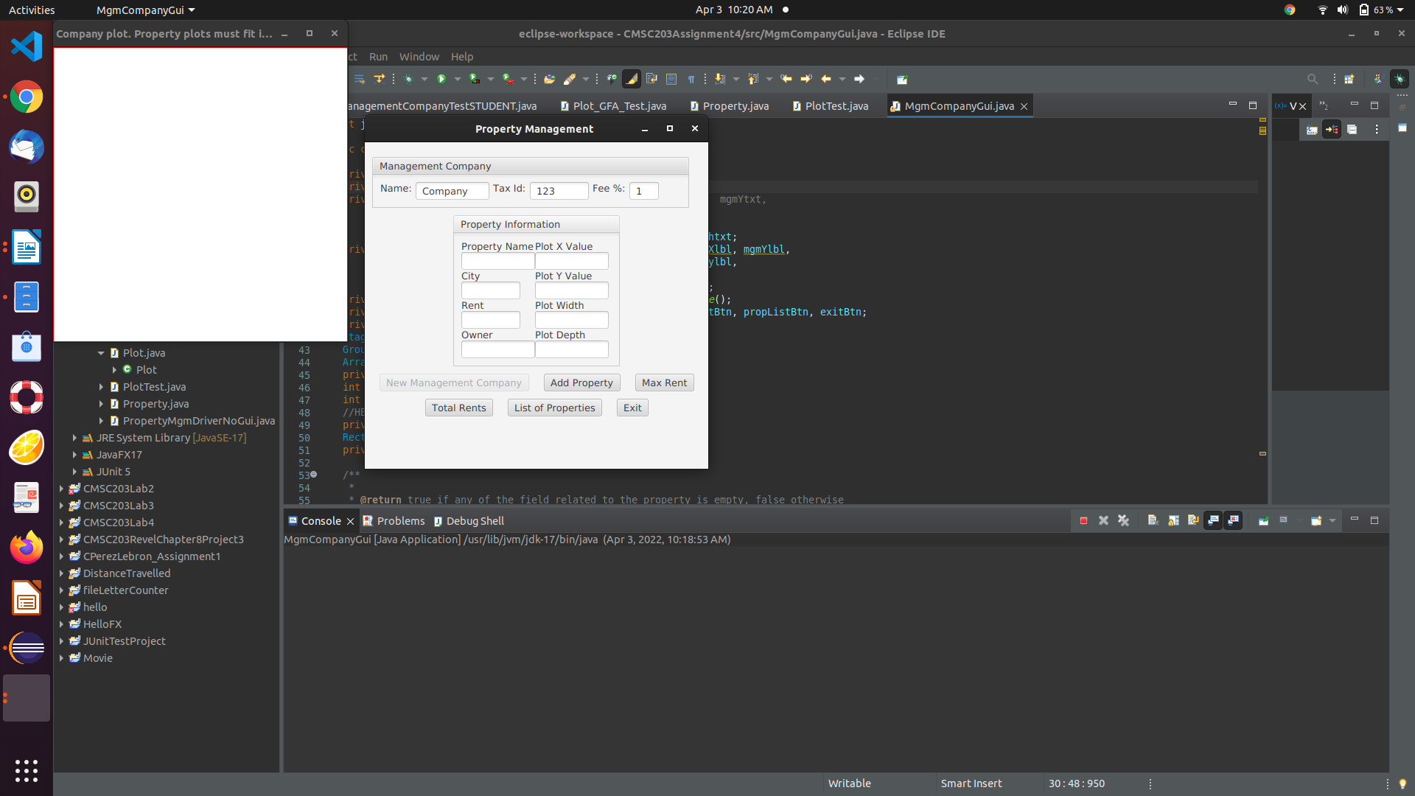

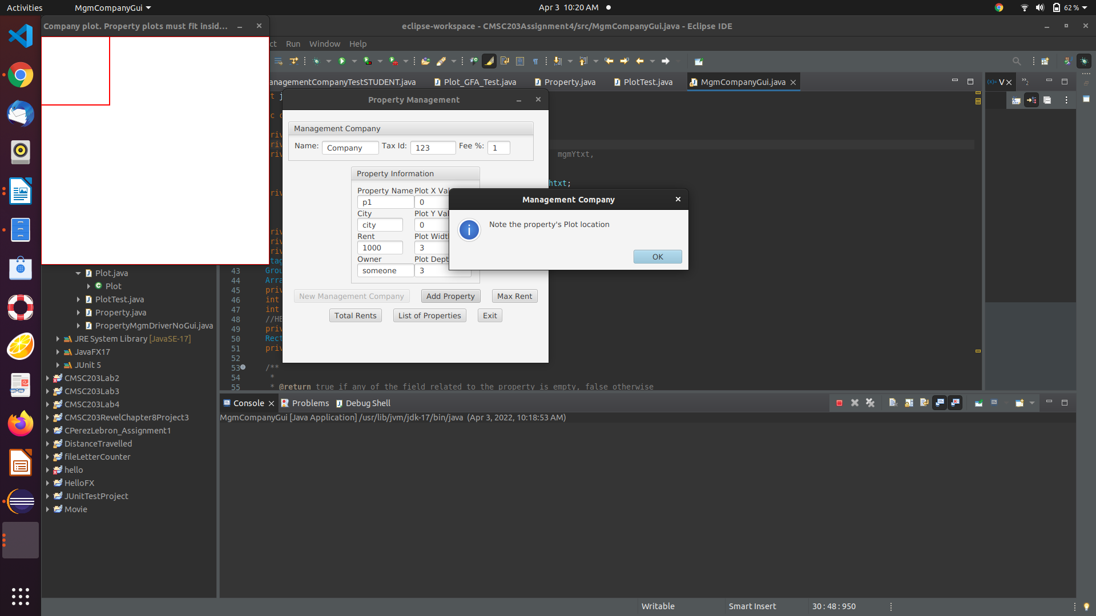

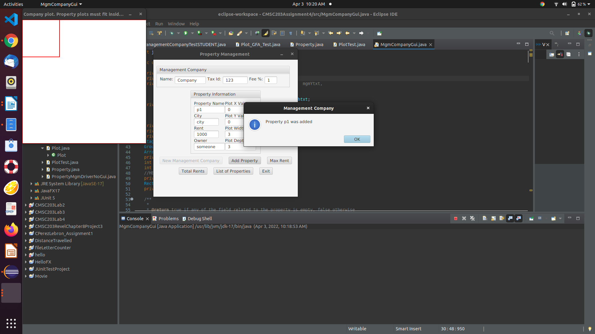

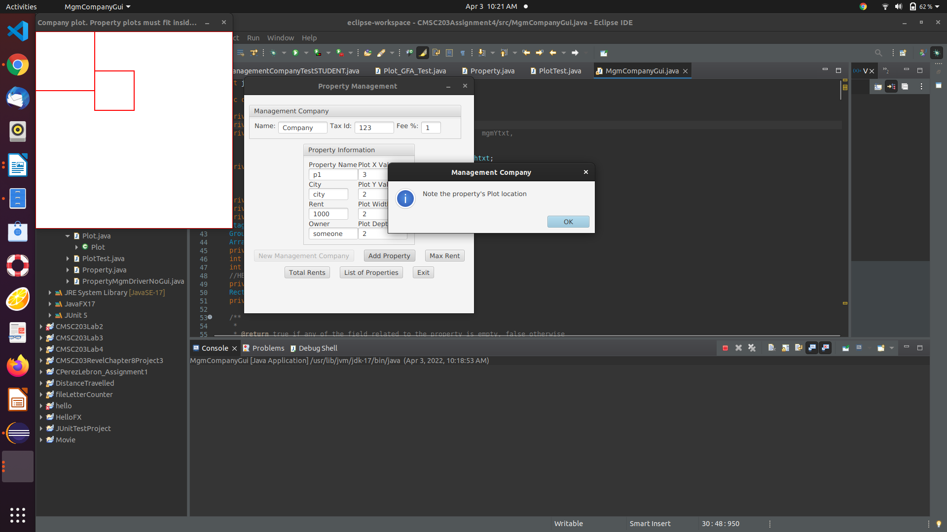

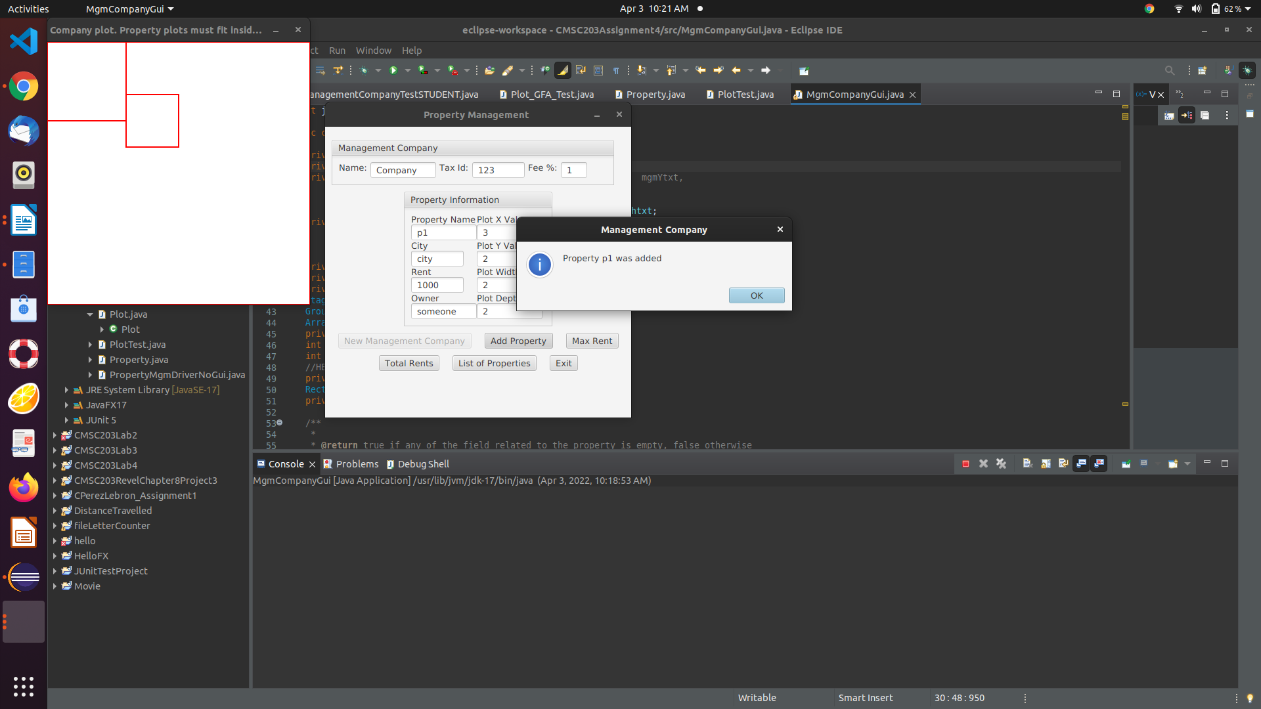

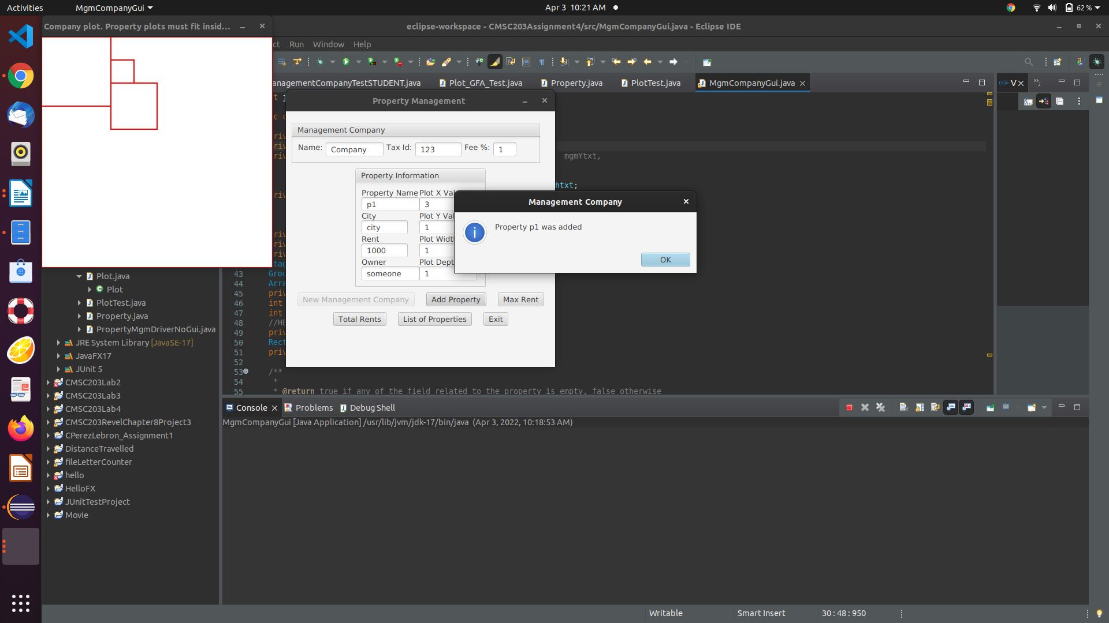

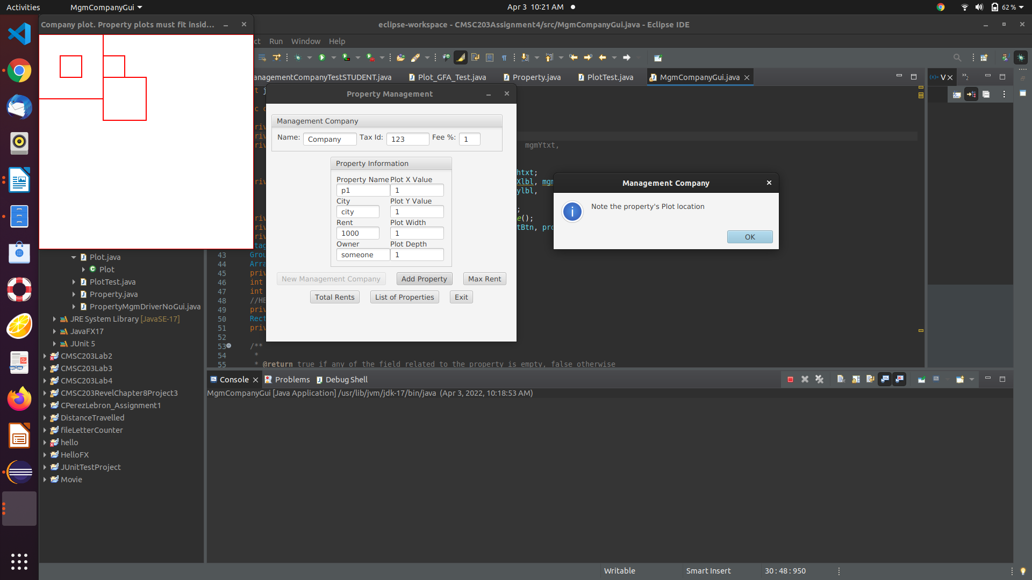

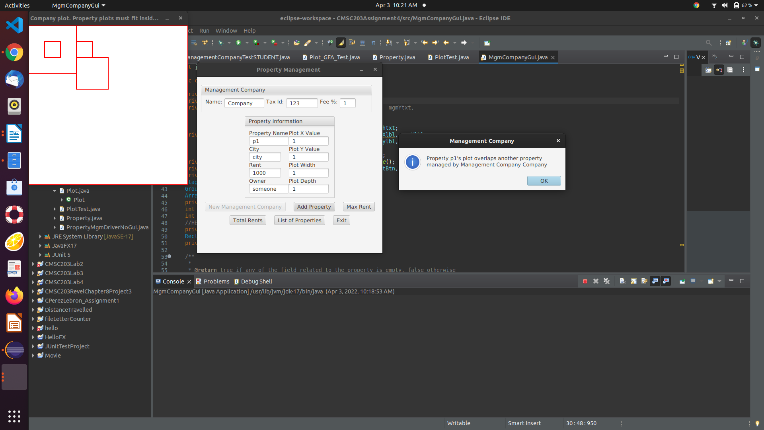

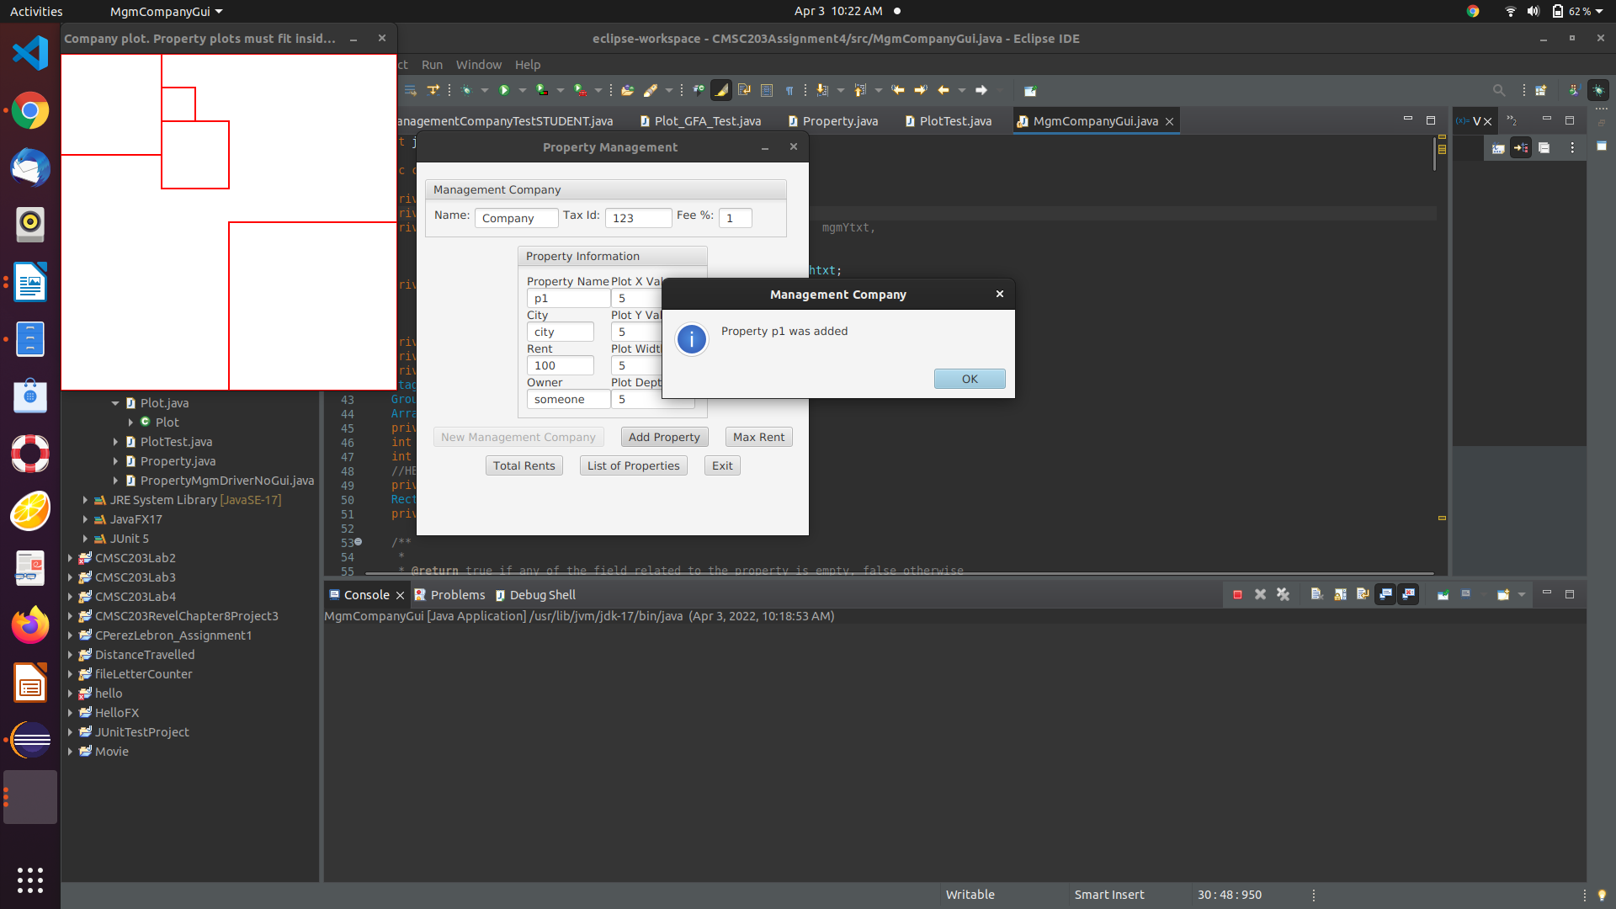

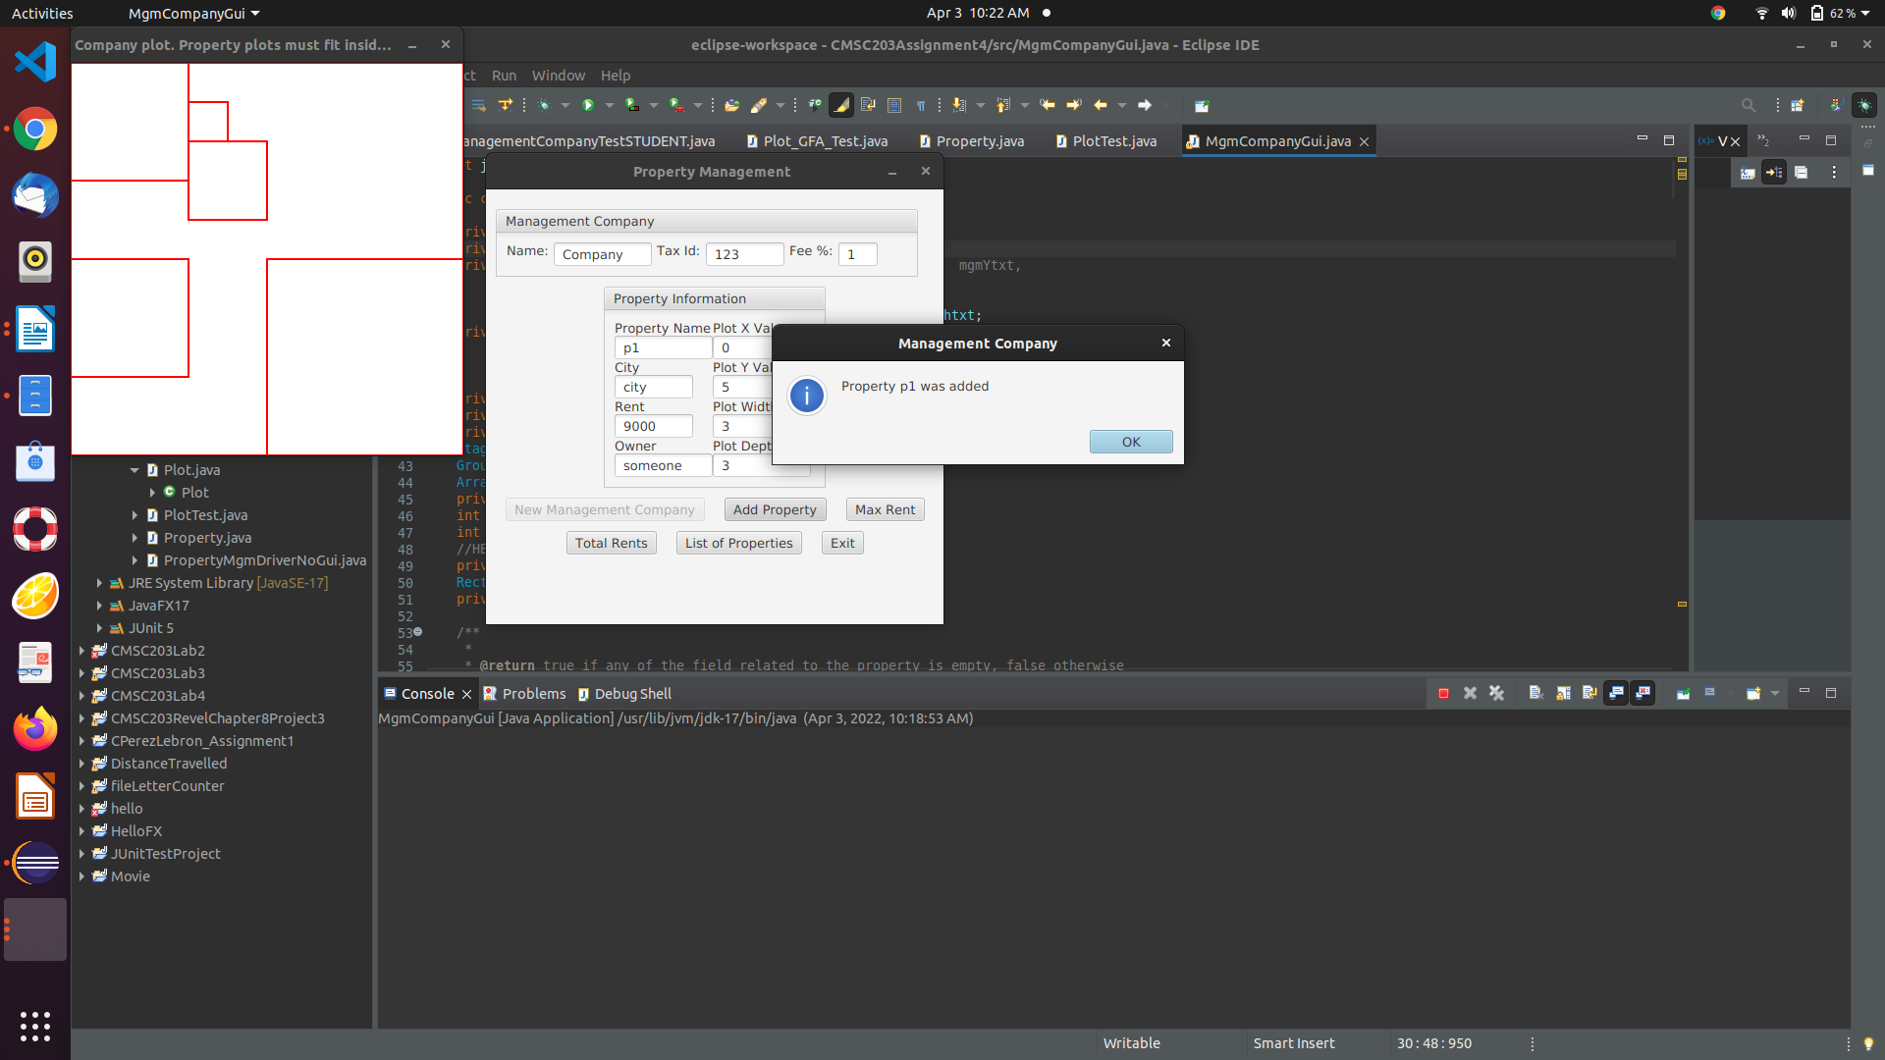

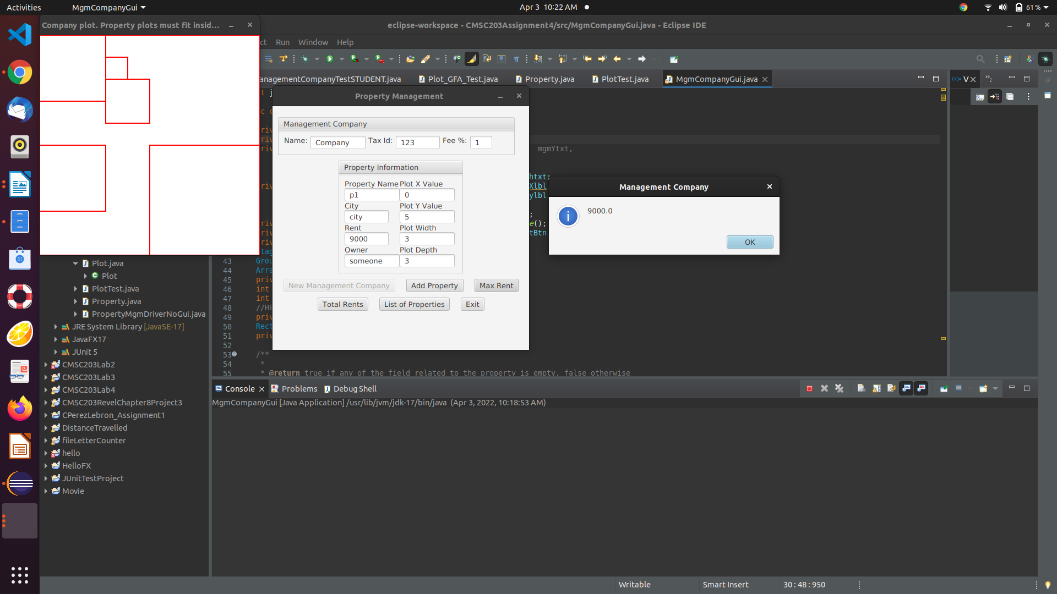

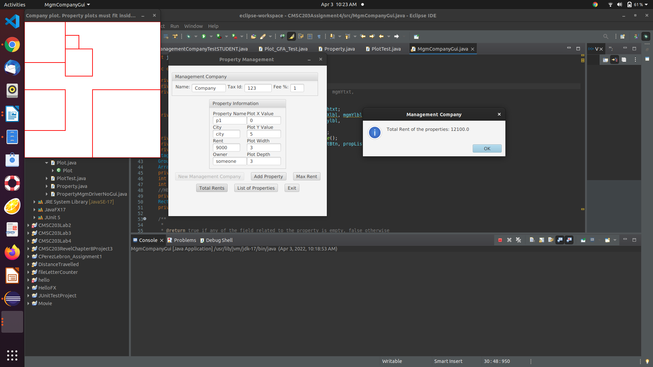

4) Screenshots of Junit

